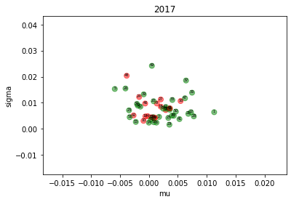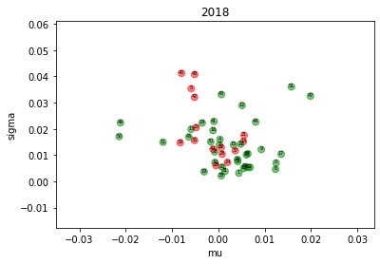

1. Are there any "obvious" patterns? For example, for

higher mu and sigma are there more green points?

For Year 2017, it seems that there are more green points for lower sigma and higher mu.

For Year 2018, it also seems there are more green points for lower sigma and higher mu.

2. Are points of the same color located close to each other?

For both year, the points of the same color are not very close to each other and they seem to mix up with each other.

3. Do patterns repeat from year 1 to year 2?

Yes, the repeat pattern is:

There are more green points for lower sigma and higher mu.

4. Do you expect nearest-neighbor classifier trained in year

1 to do well in year 2?

No, green points and red points are mixed up with each other for both year so that the nearest-neighbor classifier has a high probability of making mistakes.